# Department of Computing

**CS-344: Web Engineering**

**Class:** BESE-11AB

# Lab 01: Configuring environment, introduction to HTML

**Date: 15.09.22**

**Name:** Tanzeel Ur Rehman

**Class:** BESE-11A

**CMS:** 345510

# Instructor: Dr. Qaiser Riaz

# 

# Lab 01: Configuring environment, introduction to HTML

### Introduction:

Students will familiarize themselves with DreamWeaver and will practically learn basic concepts of HTML.

### Lab Objectives:

This objective of this lab is to help students in setting up their systems for web engineering and familiarizing themselves with the development environments for HTML and basic concepts of HTML.

### Helping Material:

<https://www.w3schools.com/html/default.asp>

### Lab Tasks

### Task 1

With the help of Lab Engineer, install on your laptops important tools for Web Engineering such as Apache2 Web Server, PHP5, MySQL, DreamWeaver, and Eclipse for PHP etc.

### Task 2

Visit W3Schools website mentioned above. Read following three sections on the website:

* HTML Introduction
* HTML Editors
* HTML Basic

Your task is to first familiarize yourself with the following HTML tags: **DOCTYPE**, HTML, BODY, Headings (H1, H2, H3, H4, H5, H6), HTML Paragraphs (<P>), and HTML Links (<a>). Once you have learned these tags, you have to create a personal HTML page similar to the following image:

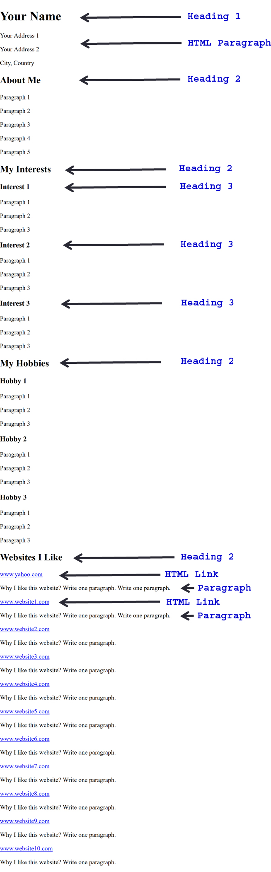

**Answer:**

|  |
| --- |
| Solution |
| Screenshot of task 2    HTML Code  <head>  <title>Lab Task 2</title>  </head>  <body>  <h1>Tanzeel Ur Rehman</h1>  <p>Address 1: House # 11 Darussalam Park University Road Sargodha</p>  <p>Address 2: Room 203  Razi 1 Hostel Nust H12 Islamabad </p>  <p>Sargodh, Punjab , Pakistan</p>  <h2>About Me</h2>  <p>I am currently in my junior year studying Software Engineering at SEECS, NUST.</p>  <h2>My Interests</h2>  <h3>Interest 1</h3>  <p>I like cooding.</p>  <h3>Interest 2</h3>  <p>I like reading books.</p>  <h3>Interest 3</h3>  <p>I like swimming.</p>  <h3>Interest 4</h3>  <p>I like traveling around the world.</p>  <h2>My Hobbies</h2>  <h3>Hobby 1</h3>  <p>I use social media in my free time.</p>  <h3>Hobby 2</h3>  <p>I do blogging in my free time.</p>  <h3>Hobby 3</h3>  <p>I like to do gardening in my free time.</p>  <h3>Hobby 4</h3>  <p>I like to drive Yaris in free time.</p>  <h2>Websites I Like</h2>  <a href="https://www.facebook.com">Facebook</a>  <p>It is a great social media platform.</p>  <a href="https://www.udemy.com">Udemy</a>  <p>It is a great learning website having a variety of courses.</p>  <a href="https://www.youtube.com">YouTube</a>  <p>It is a great website for learning and entertainment as well.</p>  </body>  </html> |

### Deliverables

Compile a single word document by filling in the solution part and submit this Word file on LMS. You must include your name, ID, and class on first page. The lab grading policy is as follows: The lab is graded between 0 to 10 marks. For some of the labs, students have to present their solutions in a viva session. In case of any problems with submissions on LMS, you should contact your lab engineer Ms. Ayesha Asif by email at [ayesha.asif@seecs.edu.pk](mailto:ayesha.asif@seecs.edu.pk)